

**COLLEGE CODE:3116**

**COLLEGE NAME: MISRIMAL NAVAJEE MUNOTH JAIN**

**ENGINEERING COLLEGE**

**DEPARTMENT:** INFORMATION TECHNOLOGY

**DATE**:02-05-2025

**TECHNOLOGY**-A SIMPLE AUTONOMOUSE WAREHOUSE ROBOT(AUTONOMOUS VEHICLES AND ROBOT)

**STUDENT NM-ID:** 90A4E56625A07439D634A85A5F

**SUBMITTED BY:**

**P.V. CHANDHANA - 311623205010**

**MOBILE NO: 7904008716**

**INDEX-PROJECT DEMONSTRATION AND DOCUMENTATION**

|  |  |  |
| --- | --- | --- |
| **S.NO** | **DESCRPTION** | **PAGE NO** |
| 1. | ABSTRACT AND PROJECT DEMONSTRATION | 3-4 |
| 2. | PROJECT DOCUMENTATION | 4-5 |
| 3. | FEEDBACK AND FINAL ADJUSTMENTS | 5 |
| 4. | FINAL PROJECT REPORT SUBMISSION  PROJECT HANDOVER AND FUTURE | 5-6 |
| 5. | WORKS | 6-10 |

**PROJECT DEMONSTRATION & DOCUMENTATION**

DOMAIN NAME: ARTIFICIAL INTELLIGENCE

TOPIC: AUTONOMOUS VEHICLES AND ROBOTICS

PROJECT TITLE: A SIMPLE AUTONOMOUS WAREHOUSE ROBOT

DONE BY: D.MAHALAKSHMI, P.V.CHANDHANA, D.MANJUSREE, M.RANJITHA, M.JAYABHARATHY

DEPARTMENT OF INFORMATION TECHNOLOGY  
MISRIMAL NAVAJEE MUNOTH JAIN ENGINEERING COLLEGE

**ABSTRACT:**

This project addresses the growing need for automation in warehousing and logistics by developing a virtual simulation of an autonomous warehouse environment. The simulation focuses on replicating the fundamental operations of autonomous robots picking up objects from specified source locations and delivering them to designated destinations within the warehouse. This virtual environment enables the design, testing, and optimization of intelligent systems, providing valuable insights for warehouse operators, logistics companies, e-commerce businesses, and robotics developers.

**1.PROJECT DEMONSTRATION**

**OVERVIEW:**

* The Autonomous Warehouse Robot system will be presented to stakeholders.
* The demonstration will highlight the robot's enhanced performance, including navigation accuracy, object detection reliability, and WMS integration.
* The focus will be on showcasing the improvements achieved in Phase 4 and the robot's readiness for deployment.

**DEMONSTRATION DETAILS:**

* **Enhanced Navigation**: The robot will navigate a simulated (or real, if feasible) warehouse environment, demonstrating the effectiveness of the SLAM implementation. This will include navigating complex layouts, adapting to changes (e.g., moved obstacles), and showcasing improved accuracy in path following.
* **Reliable Object Detection:** The robot will perform object detection and handling tasks, highlighting the improved accuracy and robustness. This could involve identifying different types of items, handling them under varying conditions (e.g., different orientations, lighting), and showing a reduction in misidentification errors.
* **Comprehensive WMS Integration:** The demonstration will showcase the real-time communication between the robot and a WMS. This will include receiving tasks from the WMS, providing updates on task progress, updating inventory levels, and handling exceptions or errors.
* **Performance Metrics Display**: Key performance metrics, as defined in Phase 4 (Navigation Accuracy, Object Detection Accuracy, Task Completion Time, Battery Life, WMS Communication Latency), will be displayed during the demonstration. This could involve real-time graphs or charts showing the robot's performance.
* **Safety Demonstration:** The robot's safety features will be demonstrated, such as obstacle avoidance, emergency stop mechanisms, and safe handling of items.

**Outcome:**

* The demonstration will clearly illustrate the robot's enhanced capabilities and its ability to perform warehouse tasks efficiently and reliably.
* It will provide evidence of the success of Phase 4's optimization efforts.

**2.PROJECT DOCUMENTATION:**

**OVERVIEW**

* Comprehensive documentation will be provided, detailing the design, development, and operation of the Autonomous Warehouse Robot.
* The documentation will include updates and additions based on the enhancements made in Phase 4.

**Documentation Sections:**

* **System Architecture:** This section will be updated to reflect any changes to the robot's architecture during Phase 4, such as the implementation of SLAM or changes to the WMS integration modules.
* **Code Documentation:** The code documentation will be updated to include details of the new algorithms, models, and integration methods implemented in Phase 4. This will be crucial for maintainability and future development.
* **User Guide** (Updated): The user guide will be updated to reflect any changes in the robot's operation or interface resulting from the Phase 4 enhancements.
* **Administrator Guide**: The administrator guide will be updated to include instructions for configuring, calibrating, andmaintaining theenhanced systems, such as the SLAM system or the improved WMS integration.
* **Testing Reports**: This section will include detailed reports on the testing conducted in Phase 4, with a focus on the performance metrics andthe improvements achieved. This will provide evidence of the effectiveness of the optimization efforts.

**Outcome:**

* The documentation will provide a complete and up-to-date reference for the Autonomous Warehouse Robot, facilitating its deployment, operation, and future development.

**3.FEEDBACK AND FINAL ADJUSTMENTS:**

**Overview:**

* Feedback will be gathered from stakeholders and users during and after the demonstration.
* This feedback will be used to make any final adjustments to the robot and its documentation before finalization.

**Steps:**

* **Feedback Collection**: Feedback will be collected through various methods, such as surveys, questionnaires, direct discussions, and observation of the robot's performance during the demonstration.
* **Refinement:** The robot's software, hardware, or operational procedures will be refined based on the feedback received. This could involve fine-tuning the navigation parameters, improving the object detection algorithms, or addressing any usability issues. The documentation will also be updated to reflect these changes.
* **Final Testing:** The robot will undergo final testing to ensure that all adjustments have been implemented correctly and that the system meets all requirements and performance goals.

**Outcome:**

* The robot will be fine-tuned and optimized based on feedback, ensuring it is ready for real-world deployment and meets the needs of its users.

.

**4.FINAL PROJECT REPORT SUBMISSION**

**Overview:**

* A comprehensive final project report will be submitted, summarizing the entire project, with a strong emphasis on the work done in Phase 4.
* This report will provide a complete record of the project's objectives, methodology, achievements, and outcomes.

**Report Sections**:

* **Executive Summary**: A concise overview of the project, highlighting the key achievements and the impact of the Phase 4 enhancements.
* **Phase Breakdown:** A detailed description of each phase of the project, with a particular focus on Phase 4 and the performance optimization efforts.
* **Challenges & Solutions**: A discussion of the challenges encountered during the project, especially in Phase 4 (e.g., difficulties in implementing SLAM, improving object detection accuracy, or ensuring robust WMS integration), and the solutions that were implemented.
* **Outcomes:** A summary of the final robot's capabilities, performance, and the benefits it provides for warehouse operations. This section will include quantitative data from the performance metrics.

**Outcome:**

* A comprehensive final project report will be submitted, providing a complete and detailed account of the Autonomous Warehouse Robot project.

**5.PROJECT HANDOVER AND FUTURE WORKS:**

**Overview:**

* The Autonomous Warehouse Robot system will be formally handed over to the stakeholders.
* Recommendations for future development and enhancements will be provided to ensure the system's continued improvement and relevance.

**Handover Details:**

**Next Steps**:

* Suggestions for future work may include:
* Scaling the system to manage a fleet of robots.
* Integrating with a wider range of WMS systems.
* Implementing more advanced AI for task planning and coordination.
* Adding capabilities for handling more complex objects or tasks.
* Exploring the use of cloud computing for robot management and data analysis.

**Outcome:**

* The Autonomous Warehouse Robot system will be successfully handed over, along with a clear roadmap for future development and improvement.

This helps develop collision-avoidance strategies and tests the robot’s ability to adapt to real-time environmental changes, making the simulation more realistic and practical.

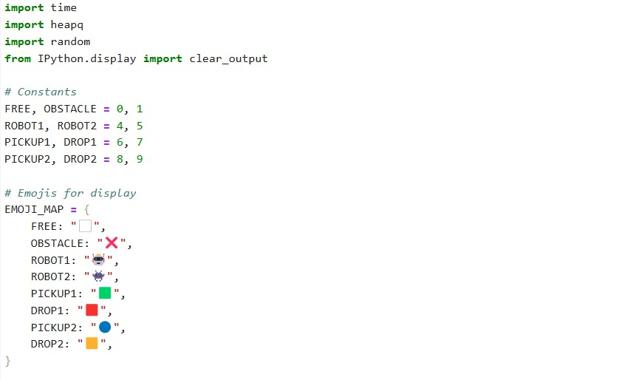**FINAL PROJECT WITH OUTPUT:**

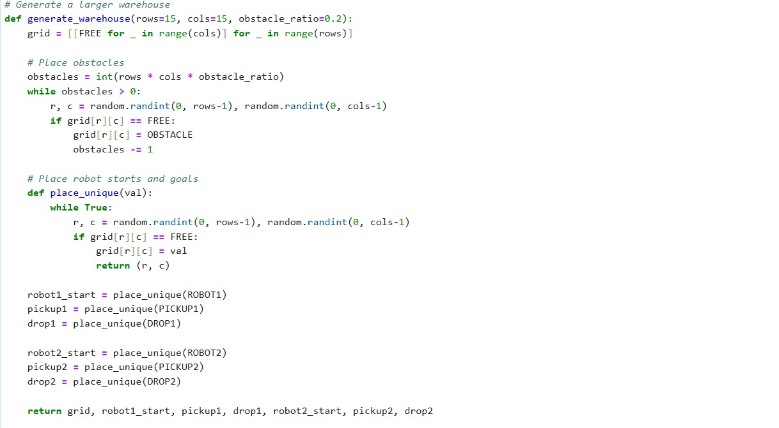

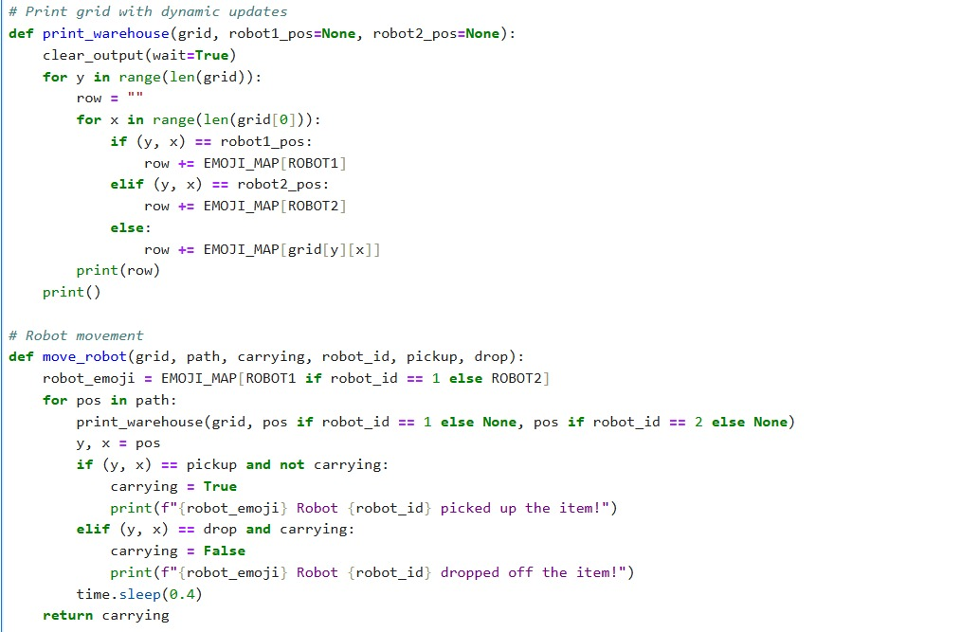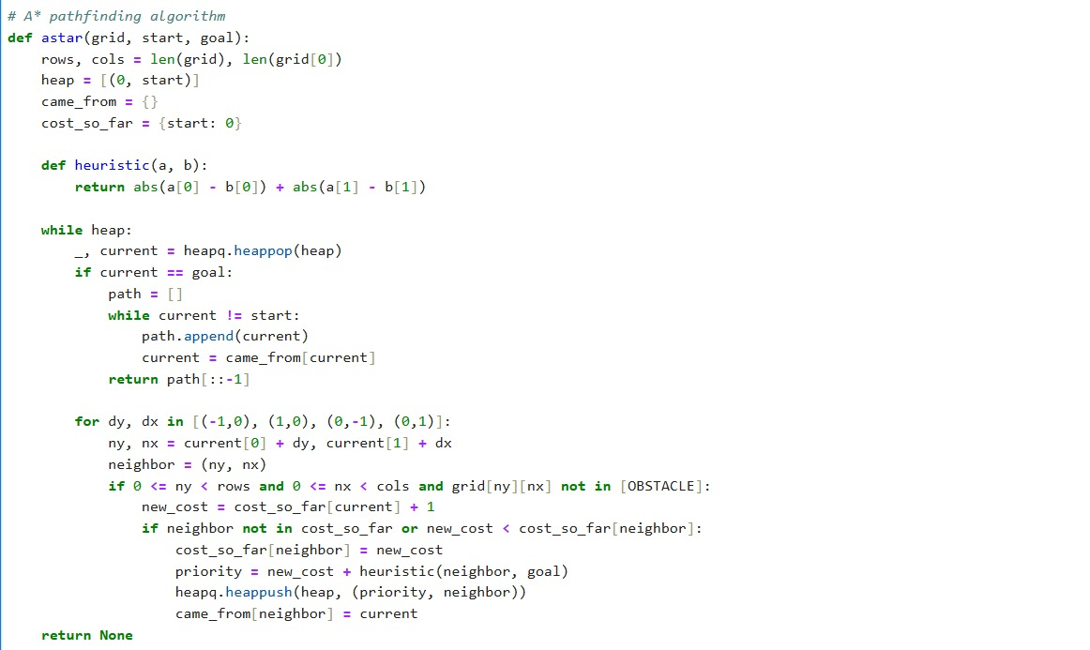

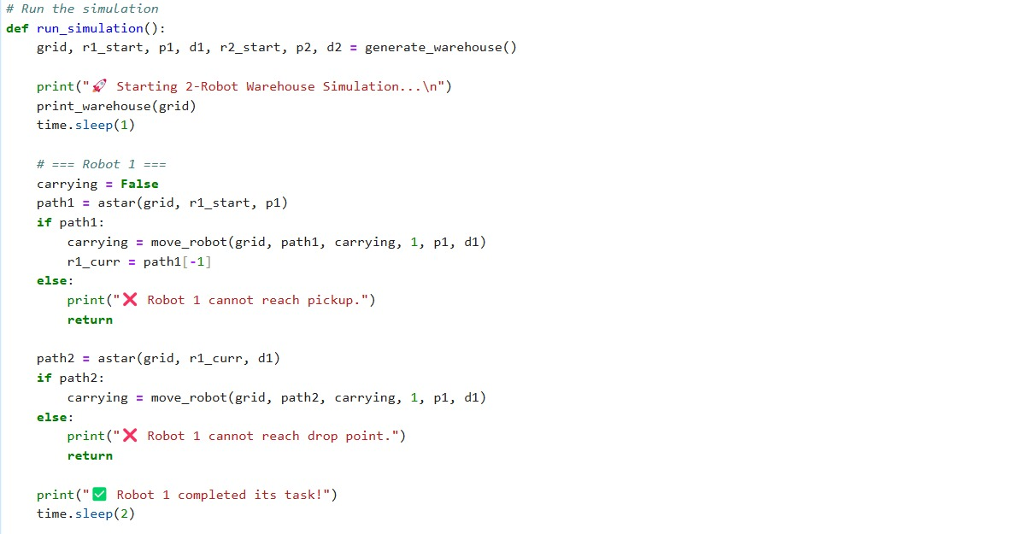

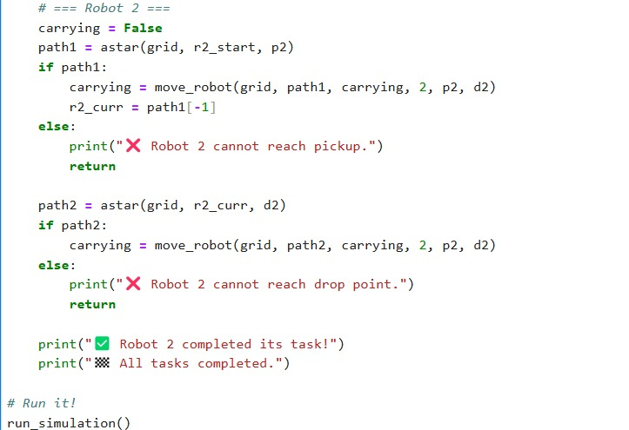



**THE OUTPUT IS ATTCHED IN THE FORM LINK ABOVE**